**Pet Shop**

**Information System**

**An Undergraduate [Capstone/Thesis] Project**

**presented to the Faculty of**

**Computer Science and Information Technology Department**

**AMA Computer College**

**123 Gen. Malvar St., Davao City**

**In Partial Fulfilment of the**

**Requirements for the Degree of**

**Bachelor of Science in Information Technology**

**by**

**Abduljabar S. Amil**

**Renaud S. Goubelle**

**TABLE OF CONTENTS**

**Page**

Title Page………………………………………………………………………………………...1

Table of Contents…………………………………………………………………………….....2

List of Tables

List of Figures

**CHAPTER 1 – INTRODUCTION**

Background of the Study……………………………………………………………4

Statement of the Problem………………………………………………………......5

Objectives of the Study…………………………………………………………......5

Significance of the Study…………………………………………………………...6

Operational Definition of Terms…………………………………………………....7   
Scope and Limitations……………………………………………………………...8

**CHAPTER 2 – REVIEW OF RELATED LITERATURE AND SYSTEMS**

Related Literature (at least 5 related literature)…….…………….…………….12

Related Systems (at least 5 related systems)………..…………………………12

**CHAPTER 3 – MATERIALS AND METHODOLOGY**

Research Design …………………………………………………………………17

Project Environment……………………………………………………………...17

Locale ………………………………………………………………………17

Population of the Study…………………………………………………..17

Research Instruments……………………………………………………17

Statistical Tools……………………………………………………………18

Timetable…………………………………………………………………...18

Data Gathering Instruments……………………………………………………...19

Data Gathering Procedures……………………………………………………....19

Methodology ……………………………………………………………………20

Requirements Specification……………………………………………....20

Use Case Diagrams …………………………………………….…10

Use Case Specifications…………………………………….……21

Program Flowchart…………………………………………….…..25

Design……………………………………………………………………....26

Project Design……………………………………………………..26

Output and User-Interface Design………………………………27

Data Design ………………………………………………………28

Development………………………………………………………………32

Software Specifications…………………………………………..32

Hardware Specifications…………………………………………32

Deployment Diagram……………………………………………..32

Test Plan…………………………………………………………..33

Test Cases………………………………………………...33

Verification, Validation and Testing………………………………………….37

Unit Testing…………………………………………………………….37

Integration Testing…………………………………………………….37

System Testing…………………………………………………….…..38

**References** 39

**CHAPTER I**

**INTRODUCTION**

This chapter presents the background of the study, statement of the problem, objectives of the study, significance of the study, scope and limitations and the definition of unfamiliar terms.

**Background of the Study**

As technology evolves students must find their specializations in the ever changing world of IT. The researchers were interested into focusing into their fields of expertise into Database Management and website programming. The researchers wanted to create a website for Pet shops and Veterinarian with a Customer and pets Database. Since technology is part of people’s everyday lives and work. Bringing Technology to business is something that has been done and will be improved on, in the future. Deciding on where and how to use it in a business is the fundamental on making the system successful.

Handling a Veterinary clinic is difficult both on the maintenance but also keeping a look out for the new medicines and technics. The clients of the pet shops would personally take time to visit and ask status of their pets and information inquiries on how to take care of the pets.

The system has a database to help the customers checking of their pet status by checking the website online, let people ask questions and order online from the comfort of their home or during a short break between the work hours online through a website. The system will keep a schedule for the veterinarian and the pet shop employees to follow.

**Statement of the Problems**

Below are the issues that the proponents need to solve:

1. Absence of clear and reliable source for next appointment.
2. Lacks reports and updates about pet.
3. Absence of proper handling of customer service.

**General Objectives**

Create a website that would promote the products for the store, handle the questions, contains a basic guide to take care of animals, appointments and keeps track of the animal’s status. A database that registers all the animals with their respective owners with an ID. Let owner check on their animal status online through the website. Let owners know about the next incoming appointments.

**Specific Objectives**

Specifically, this study aims to create:

1. Create a website with a database that allows owners to check on pets next appointments.
2. Create a Database that records the pets condition and is accessible through the website with an ID search.
3. Creates a thread that will allow other clients to see the thread’s progression.

**Significance of the Study**

This system is believed beneficial to the following:

**Researcher**

The study will be significant to the researcher for it gives experience in creating websites and database.

**Employees.**

The schedule inside the system will allow for the employees to have a better time management and an orderly schedule.

**Pet shops Company**

The study will benefit the pet shops to give a proper system and website for people to look at.

**Veterinarian**

The whole system will be beneficial to the veterinarian with a website where people can check the status of their pets and will answer some of the commonly asked question; it will also allow them to have a schedule and reminders.

**Community**

The system will benefit the people in Davao city to know more knowledge on how to handle or care their pets.

**Client**s

The clients does not need to leave the comfort of their home or spare a chunk of their time to check on their pets but instead just a quick look to the website will allow the client to see the status of his pets or tips.

**Future researchers**

The study will be beneficial to the next generation of researchers as their reference in their future researches.

**Operational Definition of Terms**

**Admin** – The person who will operate or manipulate the system. Also, the only one who has the permission to verify and modify the system.

**Client** – is the one who will make a transaction to the veterinarian like buying pet products, check the condition o their animals etc.

**Appointment** - An agreement settled between the veterinarian and the client at a particular time.

**Products** – it includes medicines, animals and pet’s food that client’s may want to purchase.

**Modify** – A process to change some parts of information that admin has the authority to modify.

**Record keeping** – a process or transaction that made between the client and veterinarian that must record.

**Status** – to show the condition of pets and if there is another transaction that must be done.

**Veterinarian** – is the one who sell pets and products. Also, the one who will check the conditions of pets and the one who will set an appointment.

**Verify**– to prove that the transaction between the veterinarian and client is true.

**Pet Shop and Veterinary Clinic** - is a shop and hospital where you can by animal and products and to check the health status of your animal.

**Services** – it includes the services for the grooming of the animals and for the treatment of the animals that the pet shop and clinic offers.

**Scope and Limitation**

The database will contain the information’s of the pets that has been recorded. The clients can see the information of their pets if they are registered.

The website can only allow the clients to check the data about their pets through a search. However, they cannot order or pay online.

**CHAPTER II**

**REVIEW OF RELATED LITERATURE AND STUDIES**

This chapter represents the overview of the related literature and studies of this special project.

**Review Related Literature**

This chapter presents the related literatures after the thorough and in-depth research. This will also present the synthesis of the art of the conceptual framework to fully understand the research to be done.

**Pet Shop Management System**

The Pet Shop Management System (PSMS) was developed by A. Noraziah (2008). The system provides the management for the pets. The system can view the information about the pets such as their services includes cleaning, scissoring, bathing, and blow drying. The flow of the system is that the client’s pet must be registered before having any services. All the important criteria such as name of an owner, the pet's name, breed, date of birth, and color need to be fulfill in the form given to the owner of the pet. If the customers want to buy any pet from the Pet Shop, they also need to fill up the transaction form and when the transaction complete, they will own the pet complete with a pet's birth certificate. The system provides a scheduler for an appointment.

**Vet Clinic Management System**

Vet Clinic Management System was developed by Lashtaar (2013, version 10). The system divides into two parts: a web application for clients and a web application for doctor and other employees. The system functionality that doctors and employees can do is that they can manage user account, manage user role, it can view the animal medical history, view the animal’s guardian, statistics and reports. The system functionality that clients can do is that they can find information about doctors and vet clinic history, check their pet’s history and also can check their animal status. The system can monitor medicine storage and dosage calculating. Furthermore, the Vet Clinic system can access to the knowledge database which storage animal’s diseases and methods for their treatment. Doctors can add own methods and can search needed information on internationally resources.

**Veterinary Clinic Web-Based Integrated Information System**

In article by KITE E-Learning solutions Inc. (2016) stated that the study sought to develop a system for the veterinary clinic to secure and manage its data. The system is design to the owner of the pet to monitor billing status and to make an appointment with the veterinarian. Also, the system is designed for easy and quick retrieval of records. The Veterinary Clinic Web-based Integrated Information System efficiently works as designed. The system is an important tool to the clinic because it provides the clinic reliable and most secured data preservation. With the developed system, the clinic can daily operate more efficiently as it manages information electronically. Information can easily be stored and retrieved. The system is designed for easy and quick retrieval of records. Also, it is designed for the pet owner to monitor billing status and to make an appointment with the veterinarian.

**Veterinary Management System**

According to Dizon (2014) in today’s generation there are many computers that are upgradable today but some institutions still do not use the high technology. One of these is the veterinarian’s clinic, veterinarians uses a manual transaction like paper written. We all know that modern veterinary are now operating at great pace striving to serve as many animal as possible with the best of their abilities. But as the years rolled by, the number of animal has grown and various medical cases arise that the manual method of managing animal records, prescriptions, billing and appointment schedule, is no longer practical. In this study, we hope to develop a land-based application that will minimize all paper works and manual records keeping, therefore allowing veterinarian ease in keeping track of animal, animal owner’s waiting time and increasing the number of animals served, a system that is fully automated, user-friendly, time effective and efficient.

The study is to develop an automated veterinary clinic record management system to avoid manual keeping of records and to minimize paper works. The system will create an automate records for patients and to create a database for the history of the patients for easy and fast access of the status and records of the animals.

**Veterinary Technology**

According to the veterinary technology by Carrington College (2014) “With the development of new veterinary technology comes the greater need for those with specialized training. Being a veterinary technician is a rewarding career for anyone who has a passion for animals. Vet techs work closely with the veterinarians to ensure that animal patients are properly cared for. In this challenging yet exciting line of work, you will be responsible for many tasks including maintaining medical records, collecting laboratory specimens and assisting with radiography and dental prophylaxes. Since the job is very demanding, it requires individuals with high levels of training. Successful vet techs will need to have completed substantial theoretical work in chemistry, biology, anatomy and physiology as well as practical work on live animals and animal simulators.”

**Review of Related Study**

The following statements given are related to their study about the human resource information system which is found very useful for the proponents in making the system.

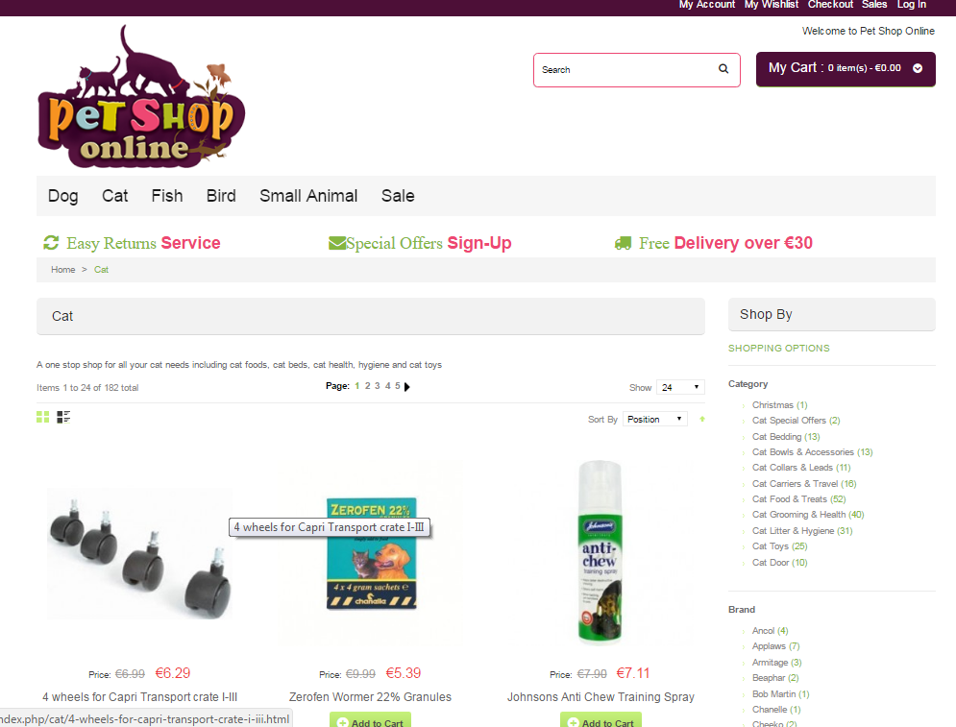

**Figure 1: Pet Shop Online**

Figure 1 on page 12 shows Pet Shop Online was established by Irish (2010), the website introduces the products they are selling same as of concept of the researchers. The system will support the proposed system of the researcher because of having similar features in selling products.

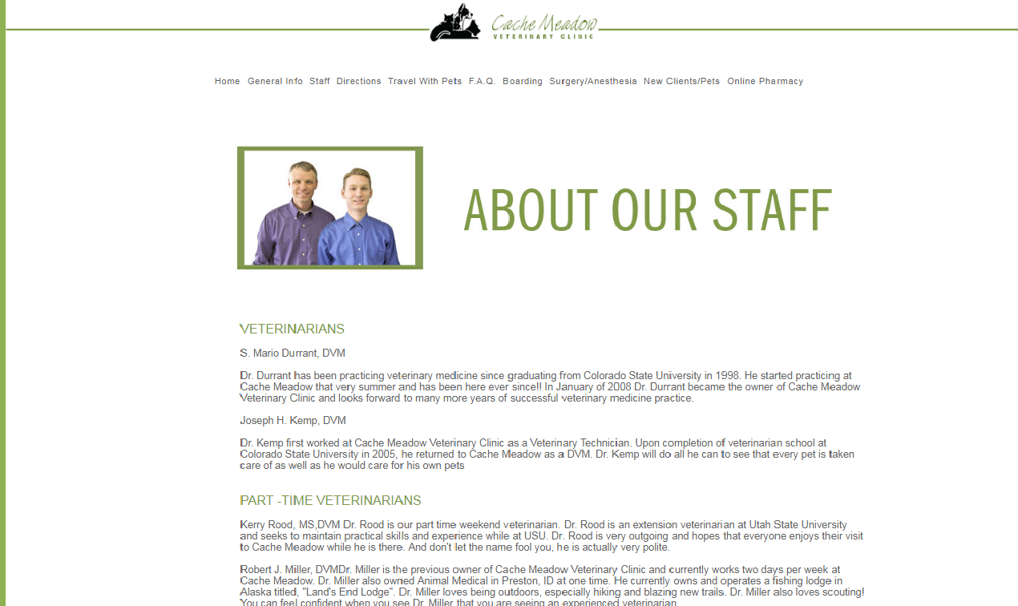 **Figure 2: Cache Meadow Veterinary Clinic**

Figure 2 shows the Website named “Cache Meadow Veterinary Clinic” by Durrant Digital (2012) both featured information system and the researcher information system share an idea of providing an information about the veterinarian and the staff of the clinic.

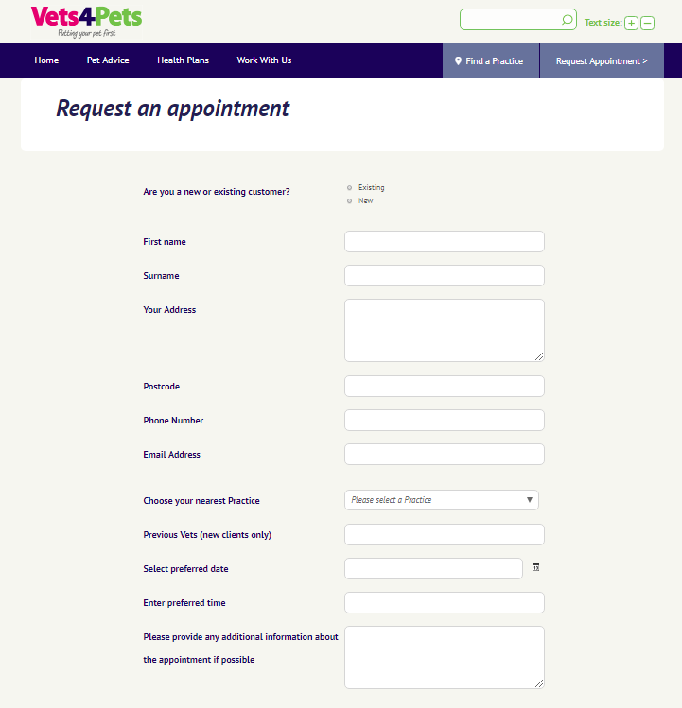

**Figure 3: Vet4pets**

Vet4pets website established in 2001 by Pets at Home both system have an appointment features. The client will fill up the form to make an appointment. Also both system will give an advice or information about the pets.

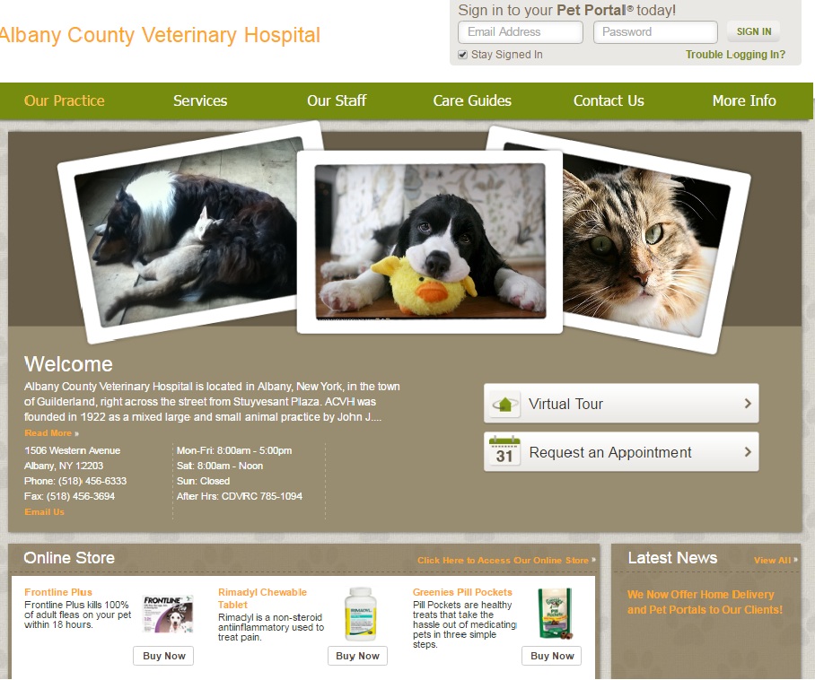

**Figure 4: Albany County Veterinary Hospital**

Figure 4 on page 14 shows Albany County Veterinary Hospital was founded in 1992 by John J. Wermuth. The website introduces their veterinarians and their services. Both systems have the same concept of services and also the way of providing a guide or information of how to take care of pets. Both systems also provide an appointment form.

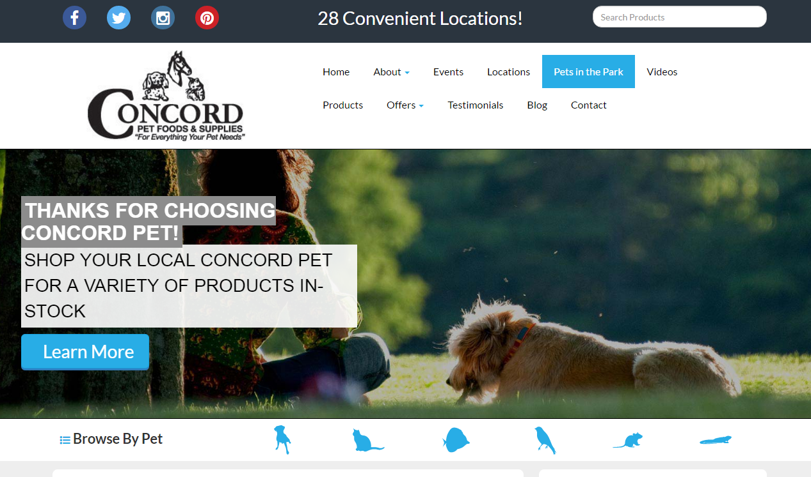

**Figure 5: Concord Pet Foods and Supplies**

Concord Pet Foods and Supplies were established by Larry Muschler(1998). This system introduces their product. The system also provides a tip on how to handle or care your animals. The website has also the same concept with the researchers proposed system since both systems has contact information.

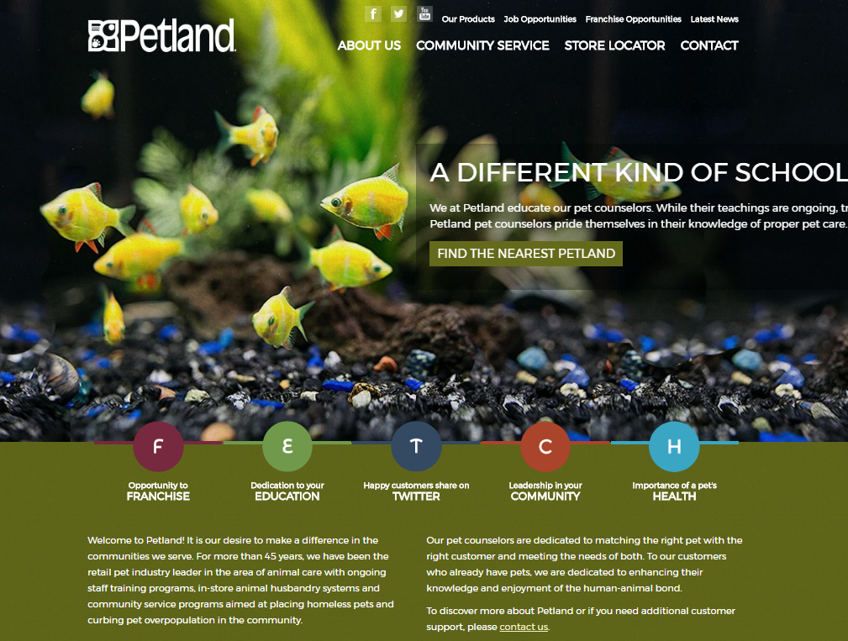**Figure6: Pet Land**

Figures 6 shows that Pet Land was founded in 1967 by Ohio Corporation. The system provides information on how to handle and love pets more. Both systems introduce their animals and their products. This Pet Land system will help the proposed system of the researcher because of some similarities. It also gives contact’s information.

**Chapter III**

**MATERIALS AND METHODS**

Presented in this chapter are the research design, project environment, procedures and methodology of the study.

**Research Design**

The data and information that the researcher gathered or acquired during the interview will make their basis to propose this design. The result of the information that the researcher gathered will make it as a guide to make some improvement of their business process. The researchers come up to propose this system design to make fast and easy business transactions.

**Project Environment**

**Locale**

The research locale of the study is the Ark Veterinary Clinic and Pet Shop located at Jacinto Extension Araullo St., Davao City.

**Population of the Study**

The populations of the study were the 70 clients/pet owners and 2 staff or administrators of Ark Veterinary Clinic who need the proposed systems.

**Research Instruments**

The researcher will conduct an interview and provide a questionnaire to gather information to conduct the study.

An interview to ask questions to the head of the Clinic and Pet Shop to gather information from their existing business process and to identify the problems of their business process while the questionnaire will be the guidance to support the researcher for the questions that they will ask to the interviewee.

**Statistical Tools**

The researchers carrying out a study include planning, designing, collecting data, analyzing, drawing meaningful interpretation and reporting of the research. The researchers will use purposive sampling focus on particular characteristics of a population.

**Timetable**

**Table 1: Project Timetable (2017-2018)**

|  |  |  |  |  |  |  |  |
| --- | --- | --- | --- | --- | --- | --- | --- |
| **PET SHOP INFORMATION SYSTEM** | | | | | | | |
| ACTIVITIES | JUN | JUL | AUG | SEP | OCT | NOV | DEC |
| RESEARCH |  |  |  |  |  |  |  |
| PLANNING |  |  |  |  |  |  |  |
| DOCUMENTATION |  |  |  |  |  |  |  |
| DESIGN |  |  |  |  |  |  |  |
| SYSTEM DEVLELOPMENT |  |  |  |  |  |  |  |

The table 1 shows the time progression and the system development of the study.

In **research** stage, the researcher looked for the best title to conduct or proposed to their capstone.

In **planning** stage, the researcher will start to plan on how they will start to achieve the proposed title.

In **documentation** stage, the researcher will document all the important information that they gathered in the study.

In **design** stage, the researcher will start to create the design of the system.

In **system development** stage, the researcher will start to improve their system with functions.

**Data Gathering Instruments**

The instruments uses in the gathering information are research, interview and questionnaire.

**Data Gathering Procedures**

In gathering the data for this study, the researcher followed these steps in order to build and gather up the progress of this web application.

1. Asked permission to propose the study.
2. Make a questionnaire to the respondent.
3. Make an appointment to the pet shop.
4. Interview together with the interviewee.
5. Transcribed the interview.
6. Validate transcription.
7. Analyze the gathered information
8. Create the system.
9. Implement the system.
10. Present the system to the panel.

**Methodology**

It contains the following: requirement specification, design, development, verification, validation and testing.

**Requirement Specification**

This part includes use case diagram and use case specification related to functions of the system.

**Use Case Diagram**

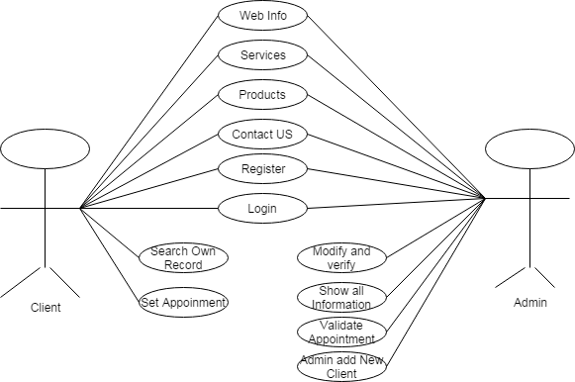

**Figure7: USE CASE Diagram for Client and Admin**

Figure 7 on page 15 shows the relation between the client and admin. The admin has an authorization to access all the functionality of the system while the client has a limited access to the system. The client can view all some important information about the pet shop he can set appointment, and reserve pets and other product of pet shop through online. Also client can contact or email the admin.

**Use Case Specification**

**Table 2: Use Case Specification-1**

(Login Client and Admin)

|  |  |
| --- | --- |
| ID | USC1 |
| TITLE | Login |
| DESCRIPTION | By logging in client must and admin must input its username and password to login. |
| PRIMARY ACTORS | Client and Admin |
| PRECONDITIONS | The admin has default login credentials and the client has given login credentials by the system. |
| POST CONDITION | Successfully Login |
| BASIC FLOW OF EVENTS | 1. Open the web application. 2. Go to login button. 3. Input username and password. 4. Click login button. 5. System will verify the login credentials. 6. The system will direct to main form. |
| EXTENSION | Username or password is invalid or incorrect.  1.1 The system will display an error. |
| FREQUENCY OF USE | Pending |
| STATUS | ON-GOING DEVELOPMENT |
| OWNER | Client and Admin |
| PRIORITY | HIGH |

**Table 3: Use Case Specification-2**

(Admin add new Client)

|  |  |
| --- | --- |
| ID | USC2 |
| TITLE | Add new Client |
| DESCRIPTION | When the client had a transaction with the admin. The client must register to create own account. |
| PRIMARY ACTORS | Client and Admin |
| PRECONDITIONS | There should be an internet connection. |
| POST CONDITION | Successfully registered. |
| BASIC FLOW OF EVENTS | 1. Open the web application. 2. Admin will go to register button. 3. Client will fill up the form. 4. System will verify the registration form. 5. The system will display successfully registered. |
| EXTENSION | Invalid input of information.  1.2 The system will display an error. |
| FREQUENCY OF USE | Pending |
| STATUS | ON-GOING DEVELOPMENT |
| OWNER | Client and Admin |
| PRIORITY | HIGH |

**Table 4: Use Case Specification-3**

(Admin will validate appointment)

|  |  |
| --- | --- |
| ID | USC3 |
| TITLE | Appointment Validation |
| DESCRIPTION | When the clients want to set an appointment to the admin, the admin will set a schedule. |
| PRIMARY ACTORS | Client and Admin |
| PRECONDITIONS | There should be an internet connection.  The admin will go to web application.  And schedule appointment. |
| POST CONDITION | Schedule settled. |
| BASIC FLOW OF EVENTS | 1. Open the web application. 2. Admin will go to appointment setter page. 3. Admin will verify the appointment and then the admin will confirm. 4. The admin will set a date and time. |
| EXTENSION | Appointment already exists.  1.3 The admin will set a new schedule for the client. |
| FREQUENCY OF USE | Pending |
| STATUS | ON-GOING DEVLOPMENT |
| OWNER | Client and Admin |
| PRIORITY | HIGH |

**Table 5: Use Case Specification-4**

(Client’s own record)

|  |  |
| --- | --- |
| ID | USC4 |
| TITLE | Client’s Record |
| DESCRIPTION | After successfully login by the owner it will view their status, information etc. |
| PRIMARY ACTORS | Client |
| PRECONDITIONS | There should be an internet connection.  Client must be logged in. |
| POST CONDITION | Successfully login. |
| BASIC FLOW OF EVENTS | 1. Open the web application. 2. Admin will go to login button. 3. Client will input username and password. 4. System will verify the login form. 5. The system will display successfully login. |
| EXTENSION | Error in username and password.  1.3 The system will display an error. |
| FREQUENCY OF USE | Pending |
| STATUS | ON-GOING DEVLOPMENT |
| OWNER | Client and Admin |
| PRIORITY | HIGH |

**Table 6: Use Case Specification-5**

(Contact Us)

|  |  |
| --- | --- |
| ID | USC5 |
| TITLE | Contact |
| DESCRIPTION | When the client want to schedule appointment or want inquire, clients can contact admin by tel. no or email. |
| PRIMARY ACTORS | Client |
| PRECONDITIONS | There should be an internet connection.  Client must visit the website. |
| POST CONDITION | Email sent to admin. |
| BASIC FLOW OF EVENTS | 1. Client must open the web application. 2. Go to “contact us” button. 3. Client will fill up the form. 4. System will verify the form. 5. The system will display successfully email sent. |
| EXTENSION | Invalid input of information.  1.2 The system will display an error. |
| FREQUENCY OF USE | Pending |
| STATUS | ON-GOING DEVLOPMENT |
| OWNER | Client |
| PRIORITY | HIGH |

**Table 7: Use Case Specification-7**

(Admin modify and verify)

|  |  |
| --- | --- |
| ID | USC6 |
| TITLE | Admin Verification |
| DESCRIPTION | When the admin wants to change some information, he can verify, modify, update and delete. |
| PRIMARY ACTORS | Admin |
| PRECONDITIONS | The admin should visit the web application. |
| POST CONDITION | Successfully updated/ created the information in the system. |
| BASIC FLOW OF EVENTS | 1. Open the web application. 2. Admin will login to admin account. 3. Verify and modify the information system. |
| EXTENSION | N/A |
| FREQUENCY OF USE | Pending |
| STATUS | ON-GOING DEVLOPMENT |
| OWNER | Admin |
| PRIORITY | HIGH |

**Table 8: Use Case Specification-8**

(Admin Show all Information)

|  |  |
| --- | --- |
| ID | USC7 |
| TITLE | Show all information |
| DESCRIPTION | Admin must be updated to the information system progression daily. |
| PRIMARY ACTORS | Admin |
| PRECONDITIONS | There should be an internet connection.  Visit web application. |
| POST CONDITION | N/A |
| BASIC FLOW OF EVENTS | 1. Open the web application. 2. Admin can view all the records and information about the system. |
| EXTENSION | N/A |
| FREQUENCY OF USE | Pending |
| STATUS | ON-GOING DEVLOPMENT |
| OWNER | Admin |
| PRIORITY | LOW |

**Program Flowcharts**

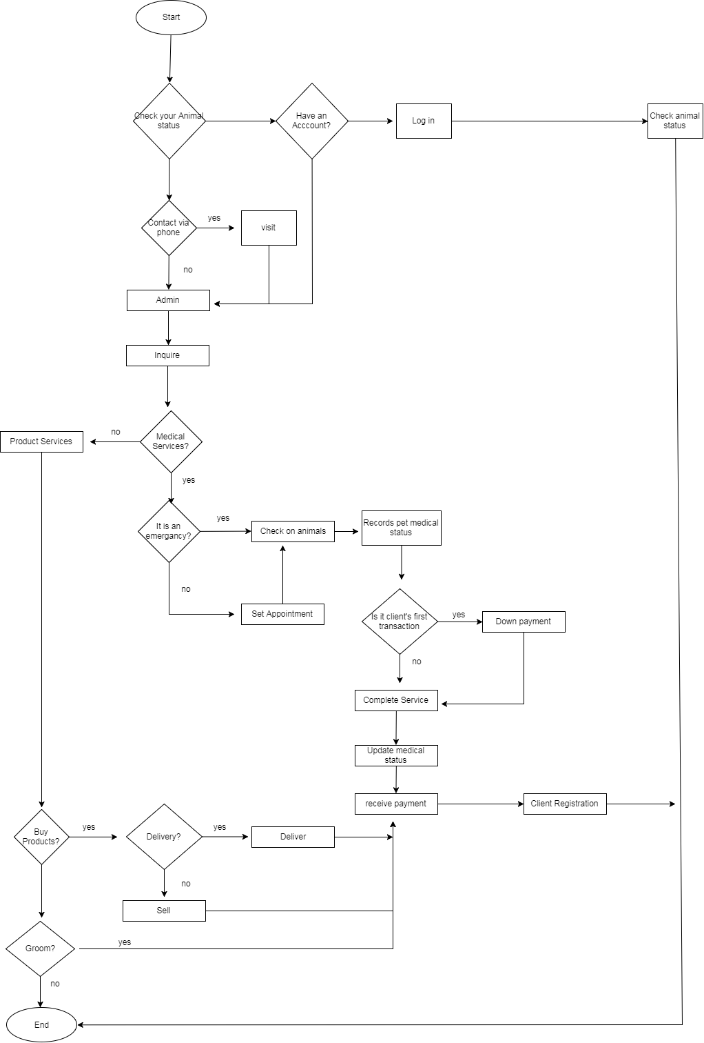

**FIGURE 11: Flowchart Diagram**

Figure 11 shows the step-by-step business process of the application from the starting point which is the login until to the end point.

**Project Design**

**Design**

This section contains the following: project design, output and user-interface design and data sign.

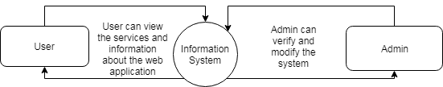

**Figure8: Level 0 Data Flow Diagram**

Figure 8 shows that the user can view the information and services about the web application while the admin have the authorization to verify and modify the system.

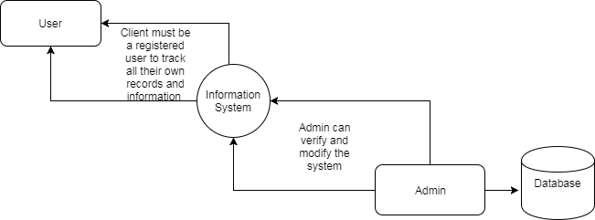

**Figure 9: Level 1 Data Flow Diagram**

Figure 9 shows that the client must be a registered user to track all the transactions he had with the admin. The admin has a database to keep all the records and transactions that has been done with the client. The admin will provide a database for client so that the client can view their own records fast and easily through online.

**Output and User-Interface Design**

**Wireframe**

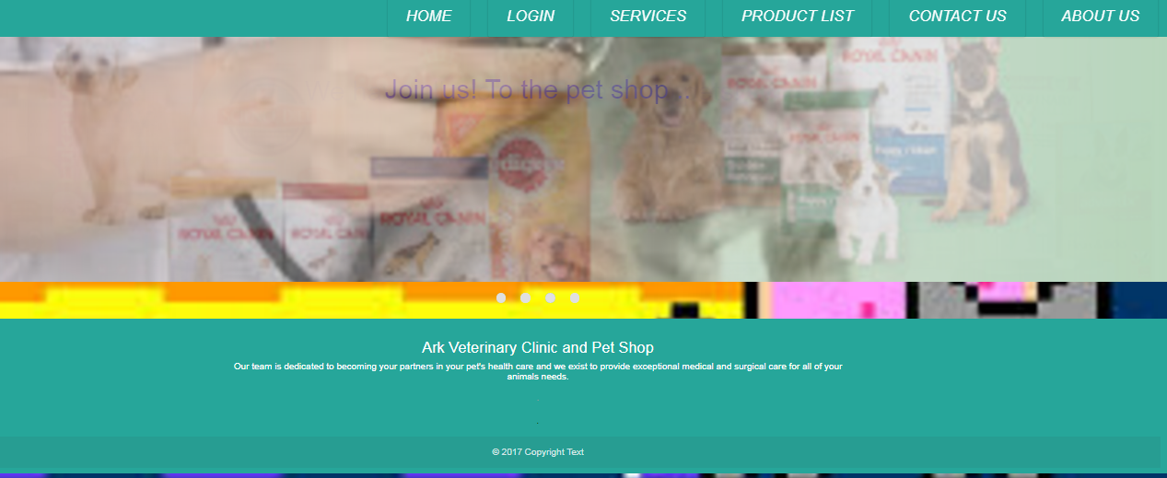

**Figure10: Home Page**

Figure 10 shows homepage of the web application. The client can view and read all the informative information about the pet shop.

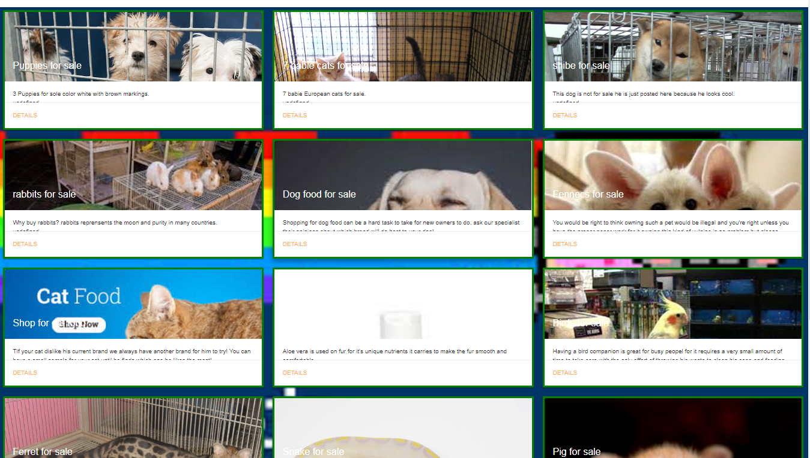

**Figure11: Product List**

Figure 11 on page 27 shows Product list of the web application. The admin can verify and modify the product lists. It has a search button to easily found the product. The product lists can view the information of the product and its price.

**Data Design**

**Table 10: Client**

|  |  |  |  |
| --- | --- | --- | --- |
| Field Name | Caption | Data Type | Field Size |
| ClientID | ClientID | Varchar | 100 |
| FirstName | FirstName | Varchar | 100 |
| MiddleName | MidleName | Varchar | 20 |
| LastName | LastName | Varchar | 100 |
| Address | Address | Varchar | 100 |
| ContactNo. | ContactNo. | Int | 50 |
| PetsName | PetsName | Varchar | 100 |
| PetsDescription | PetsDescription | Varchar | 100 |
| Time | Time | Int | 20 |
| Date | Date | Varchar | 50 |
| ClientEmail | ClientEmail | Varchar | 100 |

**Table 11: Administrator**

|  |  |  |  |
| --- | --- | --- | --- |
| Field Name | Caption | Data Type | Field Size |
| AdminID | ClientID | Varchar | 100 |
| FirstName | FirstName | Varchar | 100 |
| MiddleName | MidleName | Varchar | 20 |
| LastName | LastName | Varchar | 100 |
| Address | Address | Varchar | 100 |
| ContactNo. | ContactNo. | Int | 50 |

**Table 12: Veterinarian**

|  |  |  |  |
| --- | --- | --- | --- |
| Field Name | Caption | Data Type | Field Size |
| Veterinarian ID | ClientID | Varchar | 100 |
| FirstName | FirstName | Varchar | 100 |
| MiddleName | MidleName | Varchar | 20 |
| LastName | LastName | Varchar | 100 |
| Address | Address | Varchar | 100 |
| ContactNo. | ContactNo. | Int | 50 |
| Veterinarian Schedule | Veterinarian Schedule | Varchar | 100 |

**Table 13: Pet**

|  |  |  |  |
| --- | --- | --- | --- |
| Field Name | Caption | Data Type | Field Size |
| ClientID | ClientID | Varchar | 100 |
| PetName | FirstName | Varchar | 100 |
| PetDescription | Address | Varchar | 100 |
| PetAge | ContactNo. | Int | 50 |
| PetGender | PetsName | Varchar | 100 |
| PetStatus | PetsDescription | Varchar | 100 |
| PetDoB | Time | Int | 20 |
| PetDoD | Date | Varchar | 50 |

**Table 14: Appointment**

|  |  |  |  |
| --- | --- | --- | --- |
| Field Name | Caption | Data Type | Field Size |
| ClientID | ClientID | Varchar | 100 |
| FirstName | FirstName | Varchar | 100 |
| MiddleName | MidleName | Varchar | 20 |
| LastName | LastName | Varchar | 100 |
| Address | Address | Varchar | 100 |
| ContactNo. | ContactNo. | Int | 50 |
| PetsName | PetsName | Varchar | 100 |
| PetsDescription | PetsDescription | Varchar | 100 |
| Time | Time | Int | 20 |
| Date | Date | Varchar | 50 |
| ClientEmail | ClientEmail | Varchar | 100 |

**Table 15: Admin Add Client**

|  |  |  |  |
| --- | --- | --- | --- |
| Field Name | Caption | Data Type | Field Size |
| AddID | AddID | Varchar | 100 |
| UserName | FirstName | Varchar | 100 |
| Password | Password | Varchar | 20 |
| Date | Date | Varchar | 50 |
| Time | Time | Int | 30 |

**Table 16: Products**

|  |  |  |  |
| --- | --- | --- | --- |
| Field Name | Caption | Data Type | Field Size |
| ProductID | ProductID | Varchar | 100 |
| Name | Name | Varchar | 100 |
| Price | Price | Varchar | 20 |
| Quantity | Quantity | Varchar | 10 |

**Table 17: Change Password**

|  |  |  |  |
| --- | --- | --- | --- |
| Field Name | Caption | Data Type | Field Size |
| Veterinarian ID | ClientID | Varchar | 100 |
| UserName | UserName | Varchar | 100 |
| Password | Password | Varchar | 100 |

**SITE MAP**

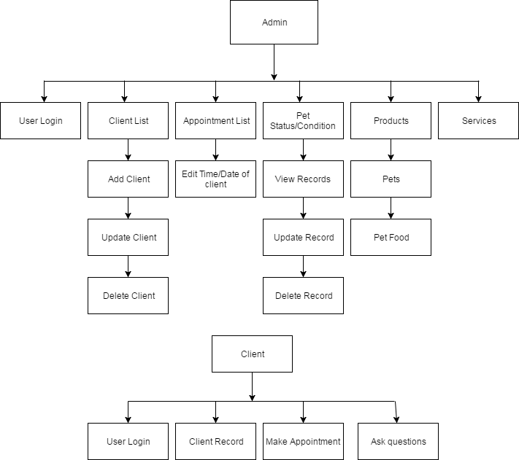

**FIGURE 12: Site map of Pet Shop Information System**

Figure 12 represents the visualization site map of the system. It shows the sequence order process flow of the system. Also, it shows all modules that it is in the system.

**Entity Relationship Diagram**

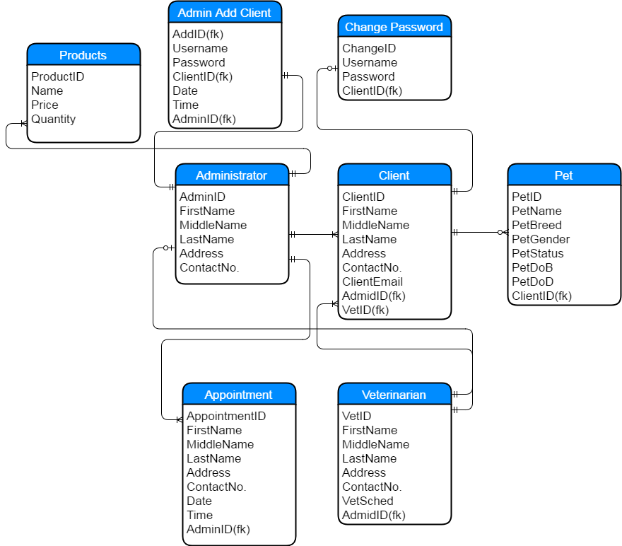

**Figure 13: Entity Relationship Diagram**

Figure 13 shows the entity relationship diagram of the system. The relationship between the client and pet is to store their information to the administrator. The administrator/staff is in charge to verify the information and transactions daily. The appointment is to set a schedule online that made by the client or the admin. The product table is to show all the available products sell by the admin such as pet and pet foods.

**Development Specifications**

**SOFTWARE SPECIFICATION**

The table shows the software specification and requirements of the online

system.

**Table 18: Software Specification**

|  |  |
| --- | --- |
| **REQUIREMENTS** | **SPECIFICATION** |
| **Web Browser** | Any version of web browsers such as Chrome, Mozilla, Internet Explorer etc. |

**HARDWARE SPECIFICATION**

The table shows the hardware specification of the system. The web application will capable to run on a modem pc or laptop.

**Table 19: Hardware Specification**

|  |  |
| --- | --- |
| **REQUIREMENTS** | **SPECIFICATION** |
| **Operating System** | Windows 7, 8, 10 |
| **Web Browser** | Any version of web browsers such as Chrome, Mozilla, Internet Explorer etc. |

**DEPLOYMENT DIAGRAM**

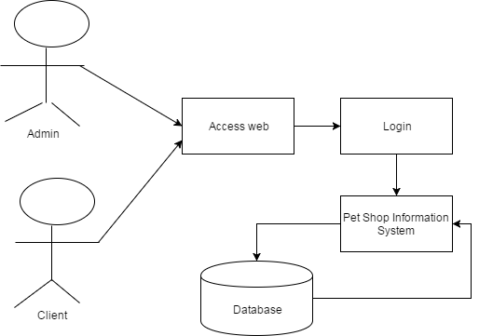

**Figure 14: Deployment Diagram**

Figure 14 on page 32 shows the deployment diagram of the system. It shows the interaction between the both users into the web application from opening the system to access the database. The system will be useful to the client to have record keeping.

**Test Plan**

**Test Cases**

**Table 20**: **Login for Client and Admin**

|  |  |  |  |  |
| --- | --- | --- | --- | --- |
| Test Case: | 1 | | | |
| Title: | Pet Shop Information System | | | |
| Description: | Test for login | | | |
| Preconditions | 1. Admin and client must be registered.  2. Internet Connection Availability | | | |
| Step | Action | Expected Result | Pass/Fail | Comment |
| 1 | Access the Web | System will Display the login button. |  |  |
| 2 | Click the “Sign in” Button | The System will display the login form |  |  |
| 3 | Fill up the loin form | The system will redirect the client and administrator to their dashboard |  |  |
| Post Condition | The admin or client as successfully login. | | | |

**Table 21**: **Admin add new Client**

|  |  |  |  |  |
| --- | --- | --- | --- | --- |
| Test Case: | 2 | | | |
| Title: | Pet Shop Information System | | | |
| Description: | Test for registration. | | | |
| Preconditions | 1. Client must done transaction to the admin  2. Client must register. | | | |
| Step | Action | Expected Result | Pass/Fail | Comment |
| 1 | Admin must Access the web | System will Display the sign up button. |  |  |
| 2 | Click the “Sign up” Button | The System will display the registration form |  |  |
| 3 | Fill up the sign up form | The system will redirect the admin to the records of the client. |  |  |
| Post Condition | The client has successfully registered. | | | |

**Table 22**: **Validate and Verify Appointment**

|  |  |  |  |  |
| --- | --- | --- | --- | --- |
| Test Case: | 3 | | | |
| Title: | Pet Shop Information System | | | |
| Description: | Test for validation and verification. | | | |
| Preconditions | 1. There should be an internet connection.  2. The admin will go to the web application.  3. Schedule an appointment | | | |
| Step | Action | Expected Result | Pass/Fail | Comment |
| 1 | Admin must Access the customer link. | Admin will verify the requested appointment. |  |  |
| 2 | The admin will click the “Set date and time” for the schedule. | Appointment settled. |  |  |
| Post Condition | The admin has successfully validated and verify the appointment. | | | |

**Table 23**: **Client’s own record**

|  |  |  |  |  |
| --- | --- | --- | --- | --- |
| Test Case: | 4 | | | |
| Title: | Pet Shop Information System | | | |
| Description: | Test for the client’s own record. | | | |
| Preconditions | 1. There should be an internet connection.  2. Client must be logged in. | | | |
| Step | Action | Expected Result | Pass/Fail | Comment |
| 1 | Client must open the web app. | The web will display the “sign in” button. |  |  |
| 2 | The admin will click the “Sign in” button. | The system will display the login form. |  |  |
| 3 | The Client will fill up the login form. | The system will redirect the client to its own records. |  |  |
| Post Condition | Client Successfully login to its own record. | | | |

**Table 25**: **Contact Us**

|  |  |  |  |  |
| --- | --- | --- | --- | --- |
| Test Case: | 5 | | | |
| Title: | Pet Shop Information System | | | |
| Description: | Test for Client | | | |
| Preconditions | 1. There should be an internet connection.  2. Open the web application. | | | |
| Step | Action | Expected Result | Pass/Fail | Comment |
| 1 | Client must open the web. | System will display the “Contact Us” button. |  |  |
| 2 | The client will click the “Contact us ” Button | System will display the contact form. |  |  |
| 3 | Client will fill up the contact form | System will display email was successfully sent |  |  |
| Post Condition | The client was successfully sent an email. | | | |

**Table 26**: **Set** **Appointment**

|  |  |  |  |  |
| --- | --- | --- | --- | --- |
| Test Case: | 6 | | | |
| Title: | Pet Shop Information System | | | |
| Description: | Test for Client | | | |
| Preconditions | 1. There should be an internet connection.  2. Client must logged in. | | | |
| Step | Action | Expected Result | Pass/Fail | Comment |
| 1 | Client must open appointment link. | System will display the appointment form. |  |  |
| 2 | Client will fill up the app. form. | System will display wait for confirmation. |  |  |
| 3 | Client will wait for confirmation. | The system will display the schedule of appointment if the admin confirmed. |  |  |
| Post Condition | The client has successfully set an appointment. | | | |

**Table 27**: **Services**

|  |  |  |  |  |
| --- | --- | --- | --- | --- |
| Test Case: | 7 | | | |
| Title: | Pet Shop Information System | | | |
| Description: | Test for Client | | | |
| Preconditions | 1. There should be an internet connection. | | | |
| Step | Action | Expected Result | Pass/Fail | Comment |
| 1 | Client must open the website. | Click the “Services" button to display the entire services offer by the pet shop. |  |  |
| Post Condition | The Client has open the services offered by the pet shop. | | | |

**Table 28**: **Show all records or information**

|  |  |  |  |  |
| --- | --- | --- | --- | --- |
| Test Case: | 8 | | | |
| Title: | Pet Shop Information System | | | |
| Description: | Test for Administrator | | | |
| Preconditions | 1. There should be an internet connection.  2. The Administrator must logged in. | | | |
| Step | Action | Expected Result | Pass/Fail | Comment |
| 1 | Admin must  Click the costumer link. | The system will display all the list of registered client. |  |  |
| 2 | Admin must  Click every costumer. | The system will display all the records and information that admin’s done with the client. |  |  |
| Post Condition | The admin has successfully seen all the records and information. | | | |

**Table 29**: **Products**

|  |  |  |  |  |
| --- | --- | --- | --- | --- |
| Test Case: | 9 | | | |
| Title: | Pet Shop Information System | | | |
| Description: | Test for Client | | | |
| Preconditions | 1. There should be an internet connection. | | | |
| Step | Action | Expected Result | Pass/Fail | Comment |
| 1 | Client must open the website. | Click the “Products" button to display all the lists of available products. |  |  |

**Verification, Validation and Testing**

Before the system was approved by the capstone adviser, the researcher verified the testing of the system. The researcher verifies the system if there is a failures or errors of the system.

**Unit Testing**

The purpose of this application is for the thesis project should be working 100% when the checking is made. Components will be tested and checked to make sure that the project is fully functional and runs accordingly.

**Integration testing**

The researchers will use tools for testing in order to know the errors and failures of the project.

**System testing**

System test will be used to evaluate the system functionality with its specific requirements and with the use of this. It will verify the Ark Veterinary Clinic and Pet shop has complied the necessary qualification of all the function and non-functional requirements. The system will be tested by the person who is in charge to operate the system.

**References:**

Dizon, J. (2014). Veterinary Management System. Retrieve from

<https://prezi.com/84-frq4v7jp_/veterenary-management-system/>

KITE E-Learning solutions Inc. (2016). Article to develop a system for the veterinary clinic.

Retrieved from

<https://ejournals.ph/article.php?id=5510>

Carrington College (2014). Devlopment of new veterinary clinic. Retrieved from

<http://carrington.edu/blog/veterinary/newest-advances-veterinary-technology/>

Noraziah, A. (2008). Pet Shop systematic through its function requirements.

Retrieved from

<http://ieeexplore.ieee.org/document/4631610/?reload=true>

Lashtaar, (2013, version 10). Monitoring system for veterinarian. Retrieved from

<https://vetclinic.codeplex.com/>